**Python FSD**

Capstone Project Solution

Online Banking Application – Phase 1



**Online Banking Application**

**Steps to be followed:**

1. Installing dependencies required for the project
2. Starting the MongoDB server and creating bankdb schema in MongoDB
3. Setting Python project
   1. Creating a workspace for VS Code
   2. Creating Virtual Environment
   3. Installing dependencies
   4. Creating a project in VS Code
   5. Creating an app within project
   6. Updating respective files for code
4. Executing the projects and testing in POSTMAN

**Step 1: Installing dependencies required for the project**

1. Please ensure that the following tools are installed in your system:

* Python 3.x
* Visual Studio Code
* Django
* Django_rest_framework
* Djongo
* pymongo
* MongoDB
* Postman Client

1. Download the following GitHub repository:

https://github.com/Kaleakash/online-baking-application-using-react-python-django.git

**Step 2: Starting the MongoDB server and creating the bankdb schema in virtual lab**

* 1. Login the virtual lab with your login details.

Here I am python lab.

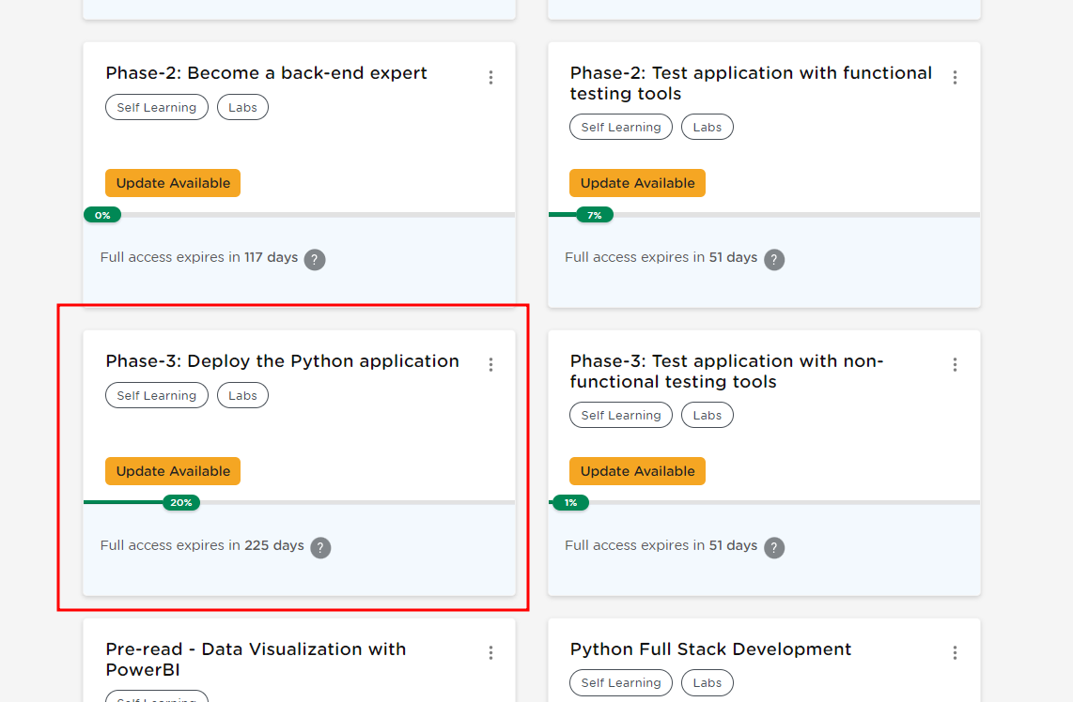

* 1. Open the terminal, and run the following command to check the MySQL server’s status:

**mongod --version**

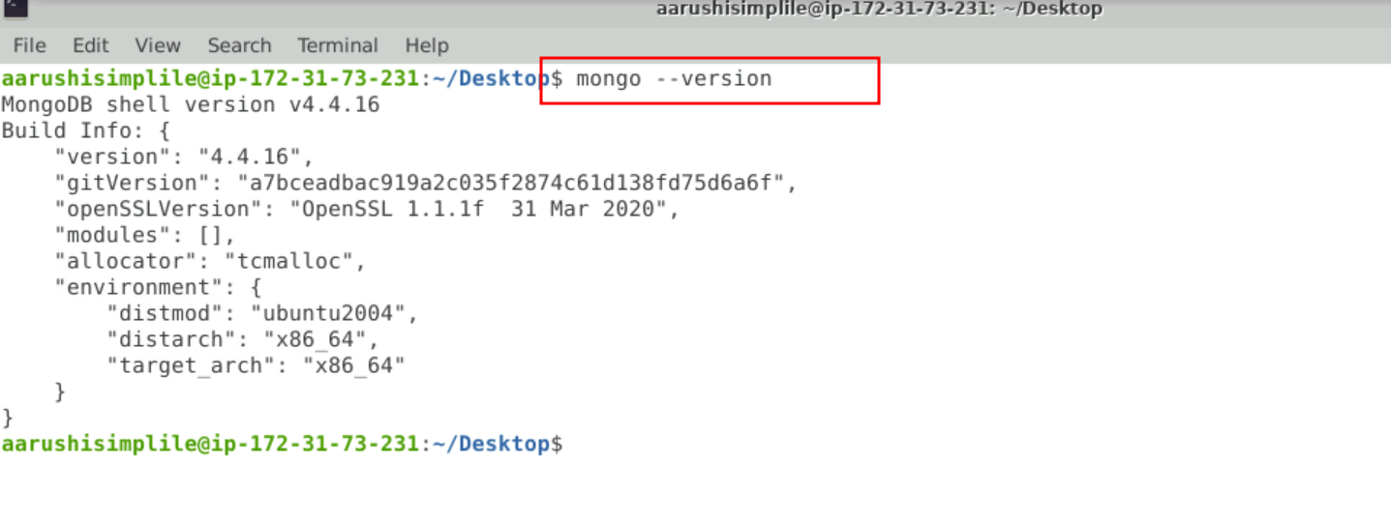

* 1. Run the following command to start the MongoDB server from the terminal

**sudo mkdir -p /data/db  
sudo mongod**

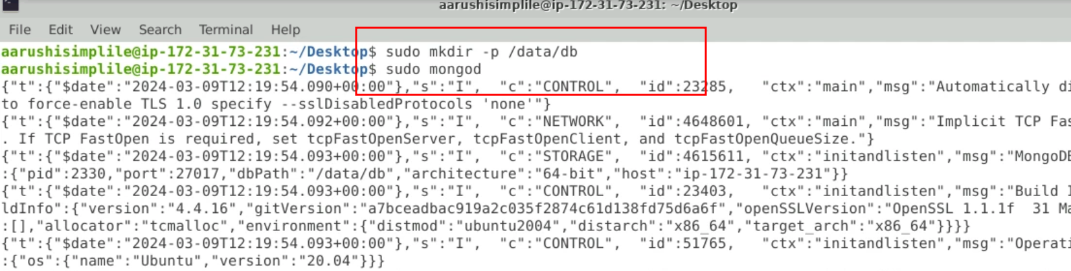

NOTE: Do not close this terminal as this is the mongo server running.

In case getting /data/db error please execute the below command:

**sudo mkdir -p /data/db**

* 1. Open another terminal and use the following command to start the mongo shell:

**sudo mongo**

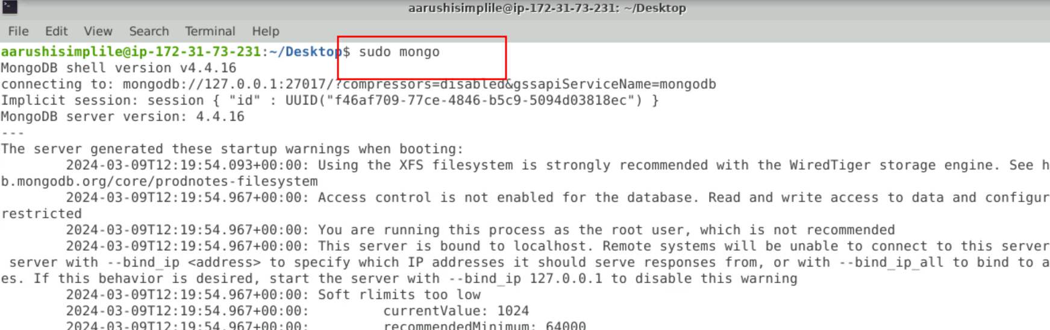

* 1. Once the mongo shell is up and running, run the below command to see existing databases:

**show dbs**

To create a database, execute the below command:

**use bankdb**

To see existing collections if any, execute the below command. It will be empty.

**show collections**

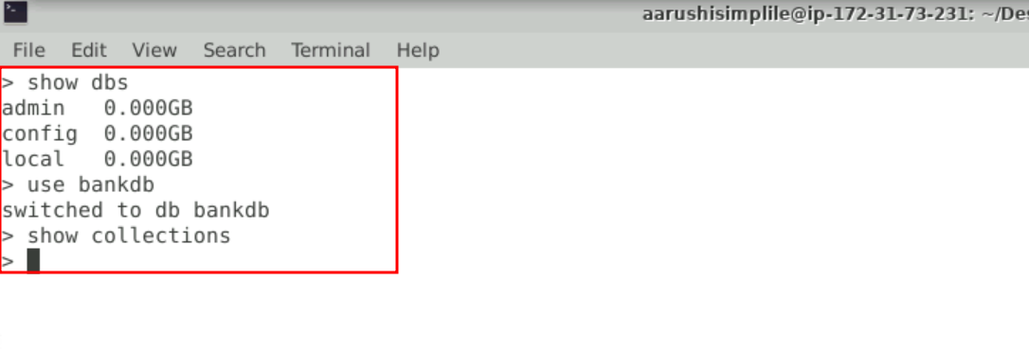

**Step 3: Now we create the environment for python to run the project.**

1. Create the folder as

**mkdir phase1-python-django-app**

1. Now we move inside this folder

**cd phase1-python-django-app/**

1. Now we need to create python virtual environment and active the virtual environment

**python3 -m venv .venv**

**source .venv/bin/activate**

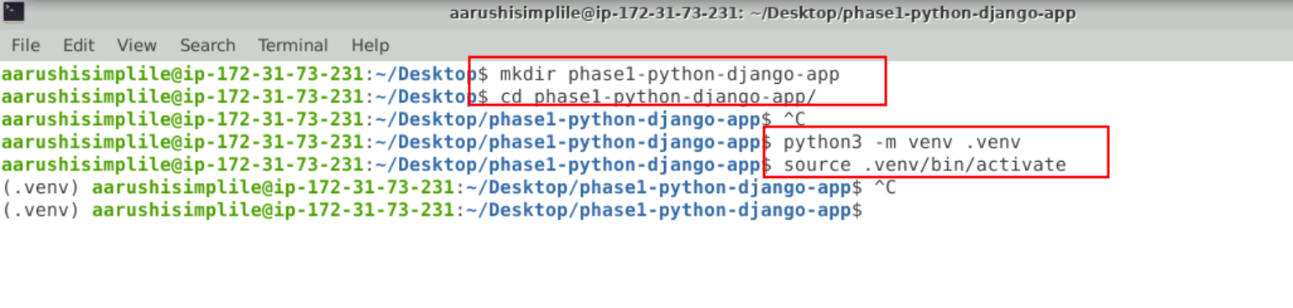

1. Now we need to install the required dependencies modules using pip command.

**pip install django it provide Django features**

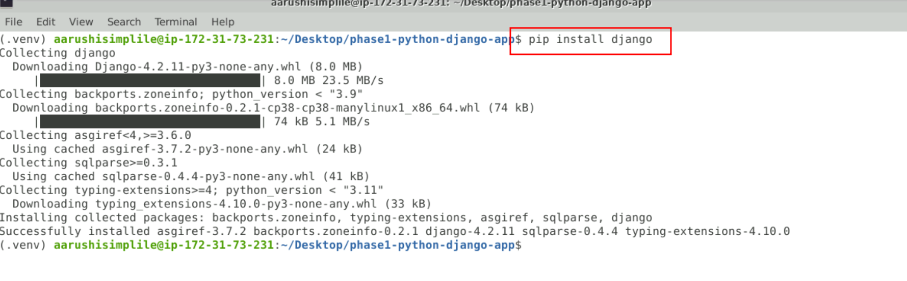

**pip install Djangorestframework it provide rest api features**

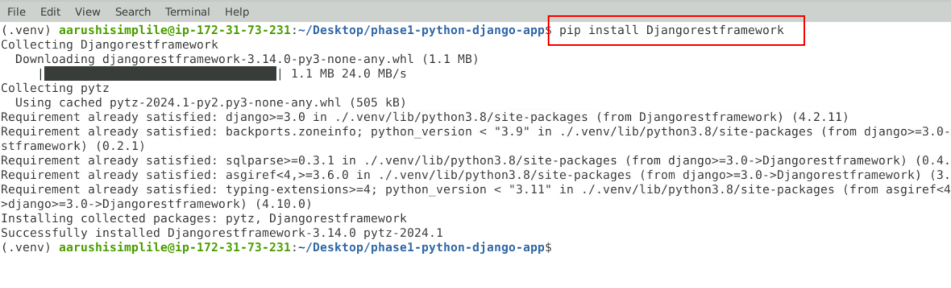

**pip install djongo this provide mongo db database adapter**

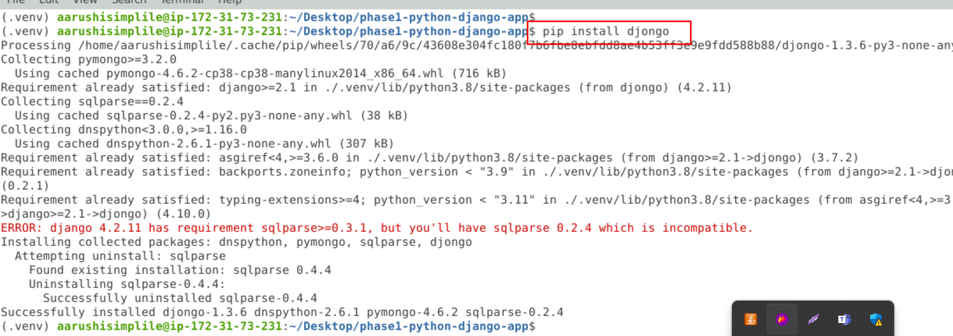

**pip install pymongo==3.12.3 it also help of mongo db database adapter.**

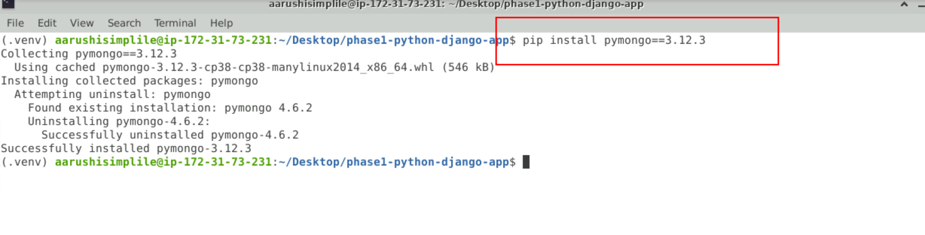

**Step 3: Now open this folder in VS code**

**3.1** open this folder in VS code**.**

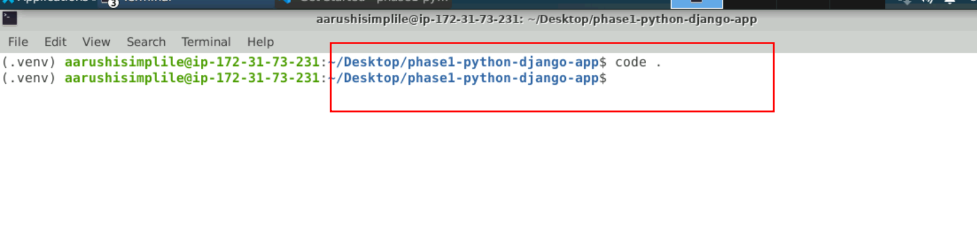

* 1. Check the django-admin version as follows:  
     **django-admin version**

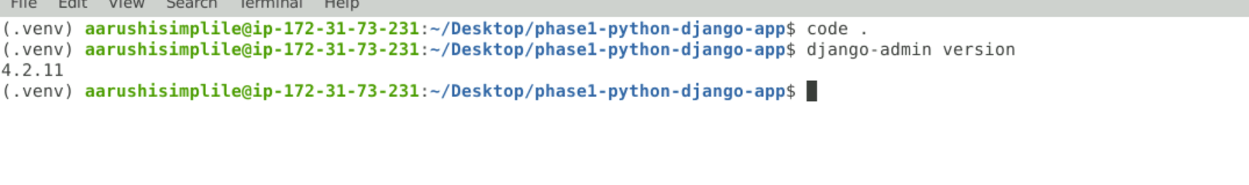

* 1. Create a Django project by executing the below command:  
     **django-admin startproject phase1bankingapp**



* 1. Execute the project by entering the phase1bankingapp folder and executing the commands below. The server should be up and running and the project available at **localhost:8000** as follows:

python manage.py runserver

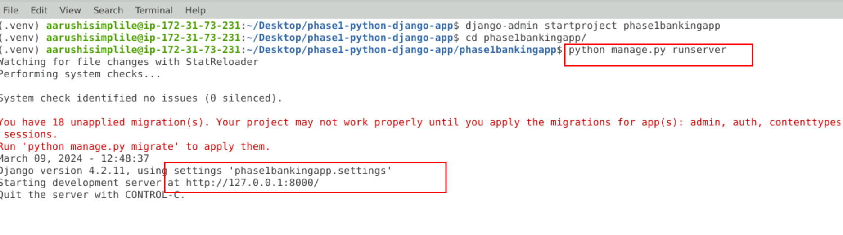  
  
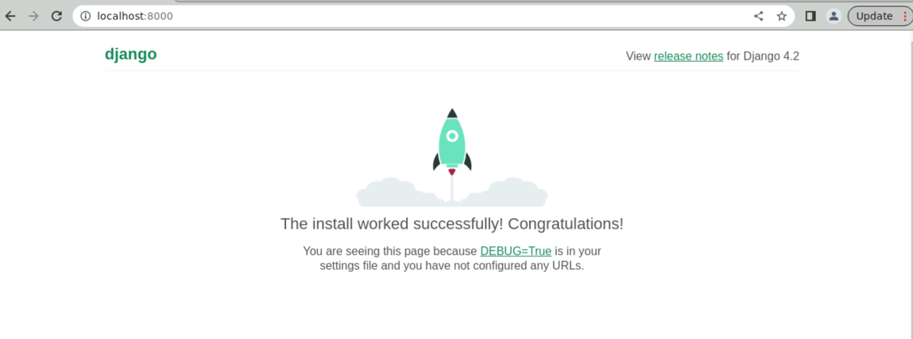

* 1. Now Hit Cntr + C to terminate the application
  2. Now we will create the app inside the project as It will create an app within the package explorer:  
     **django-admin startapp api**

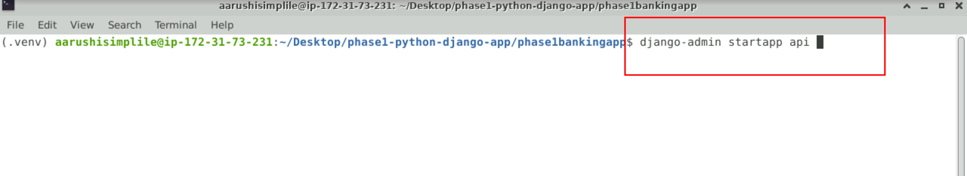

3.6 view the project structure in VS code.

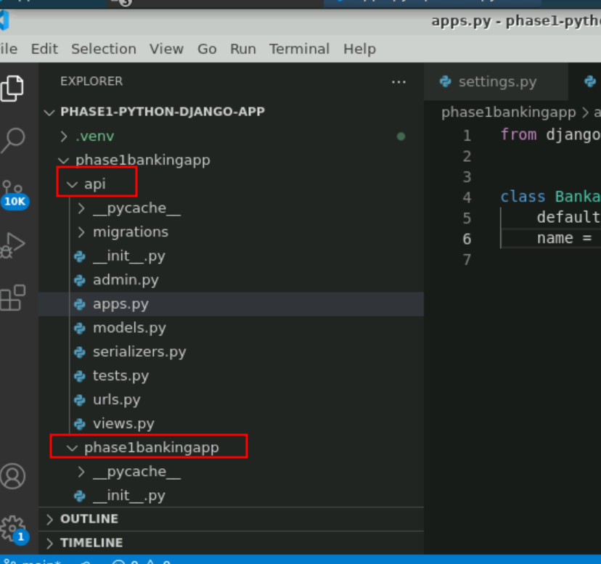

* 1. Make changes in the settings.py files for database configuration, adding apps and the authentication framework as follows:  
     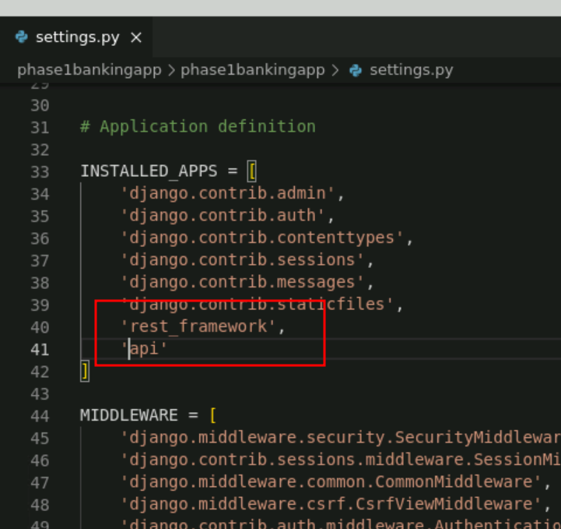
  2. By default Django use SQLite Database. But for our project we are using mogno db database so we need to do changes in database.

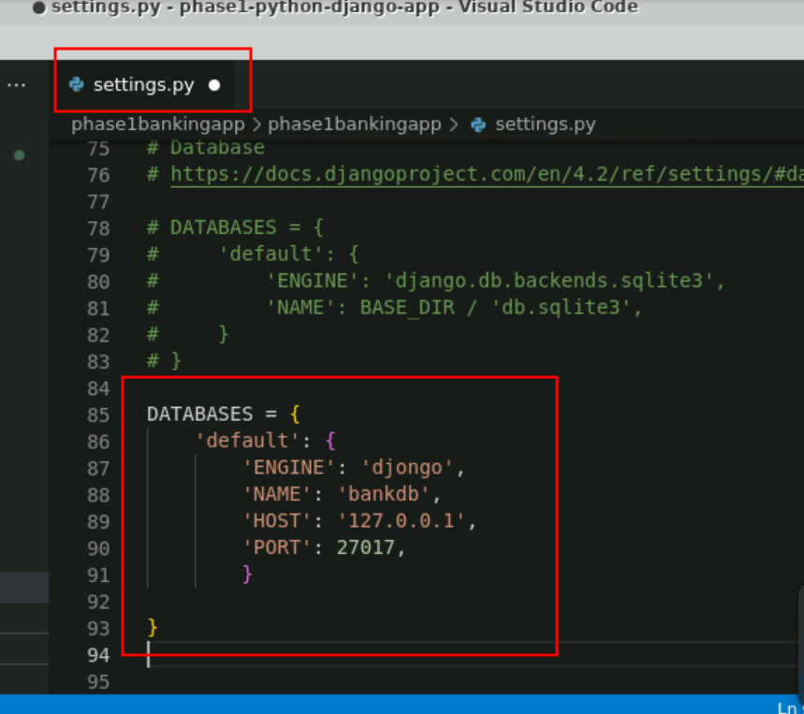

* 1. Create urls.py and serializers.py files within the bankapi folder as follows:

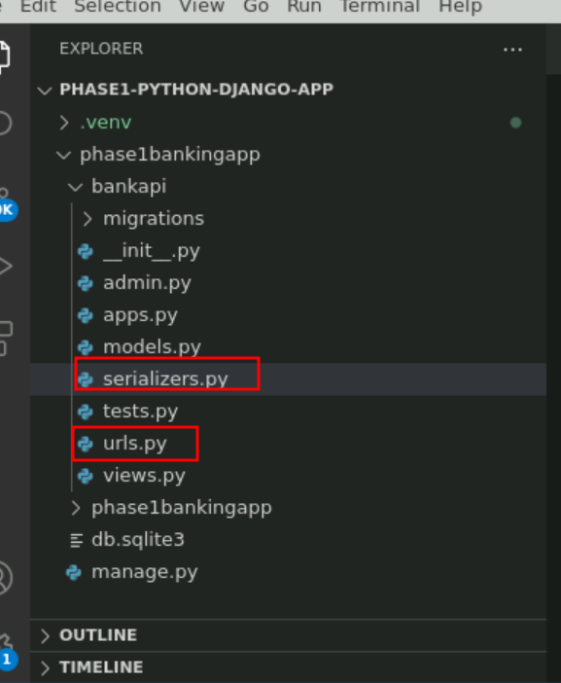

* 1. Update **models.py, urls.py, serializer.py, admin.py,vews.py** in bankapi app for your project

(Refer to GitHub repo for code)

**views.py file**

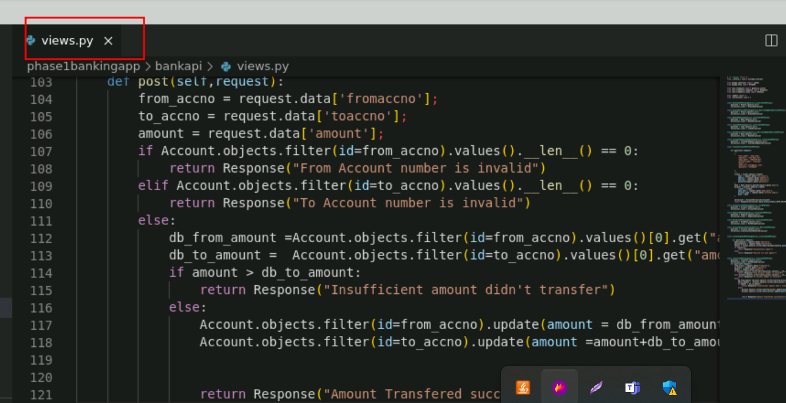

**urls.py**

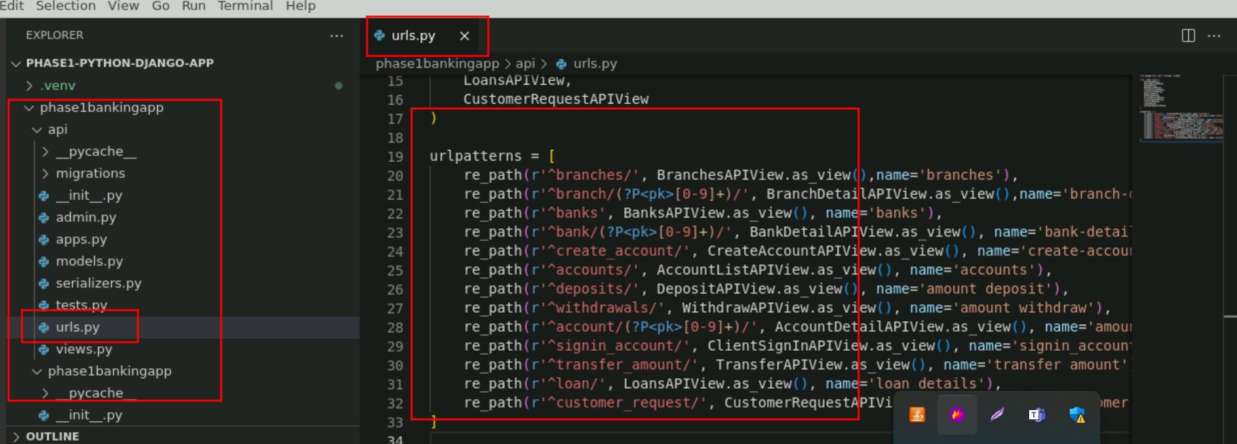

**serializer.py file**

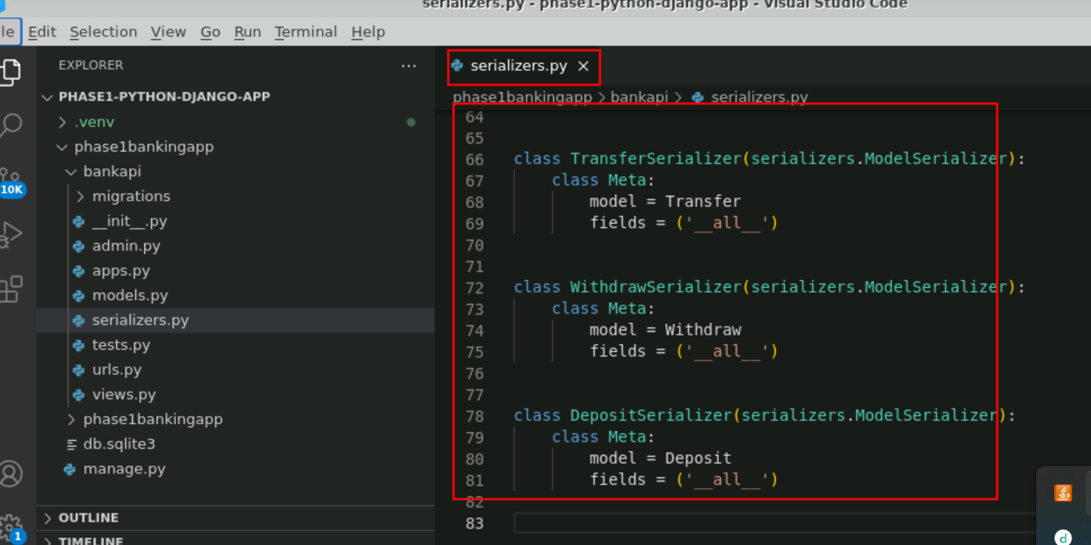

**models.py**

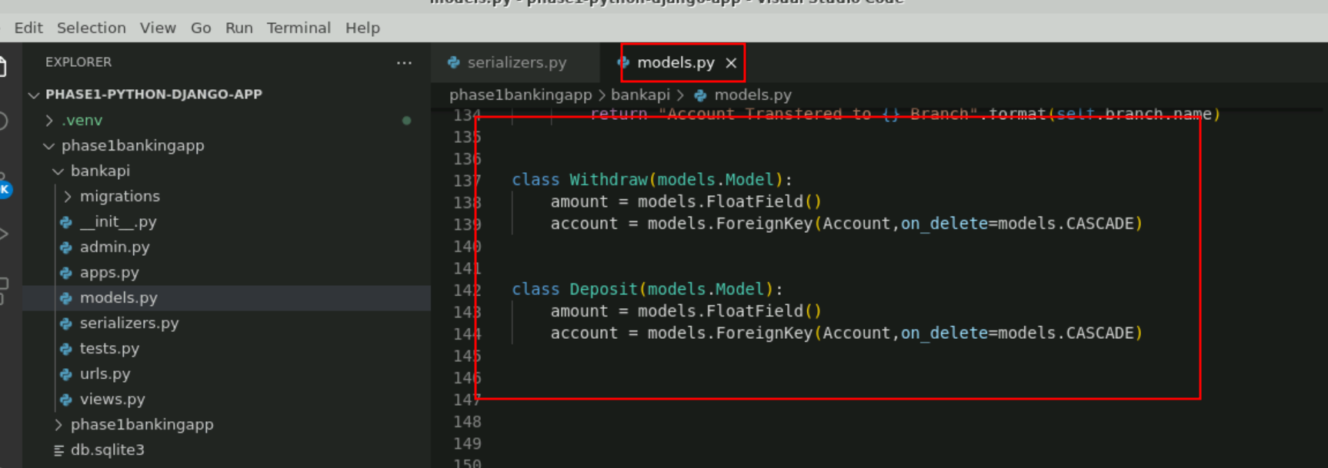

**admin.py**

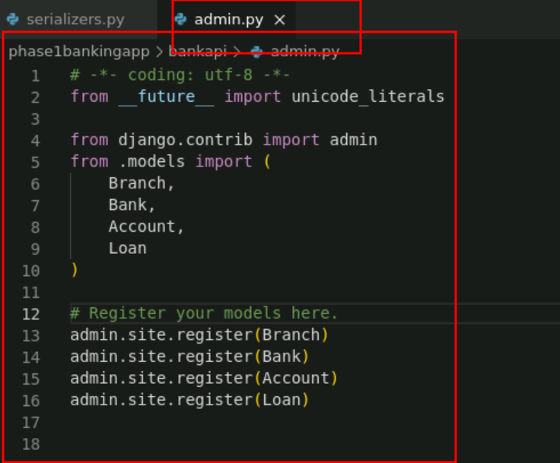

* 1. Now we need to provide the main path in url.py file part of **phase1bankingapp** folder

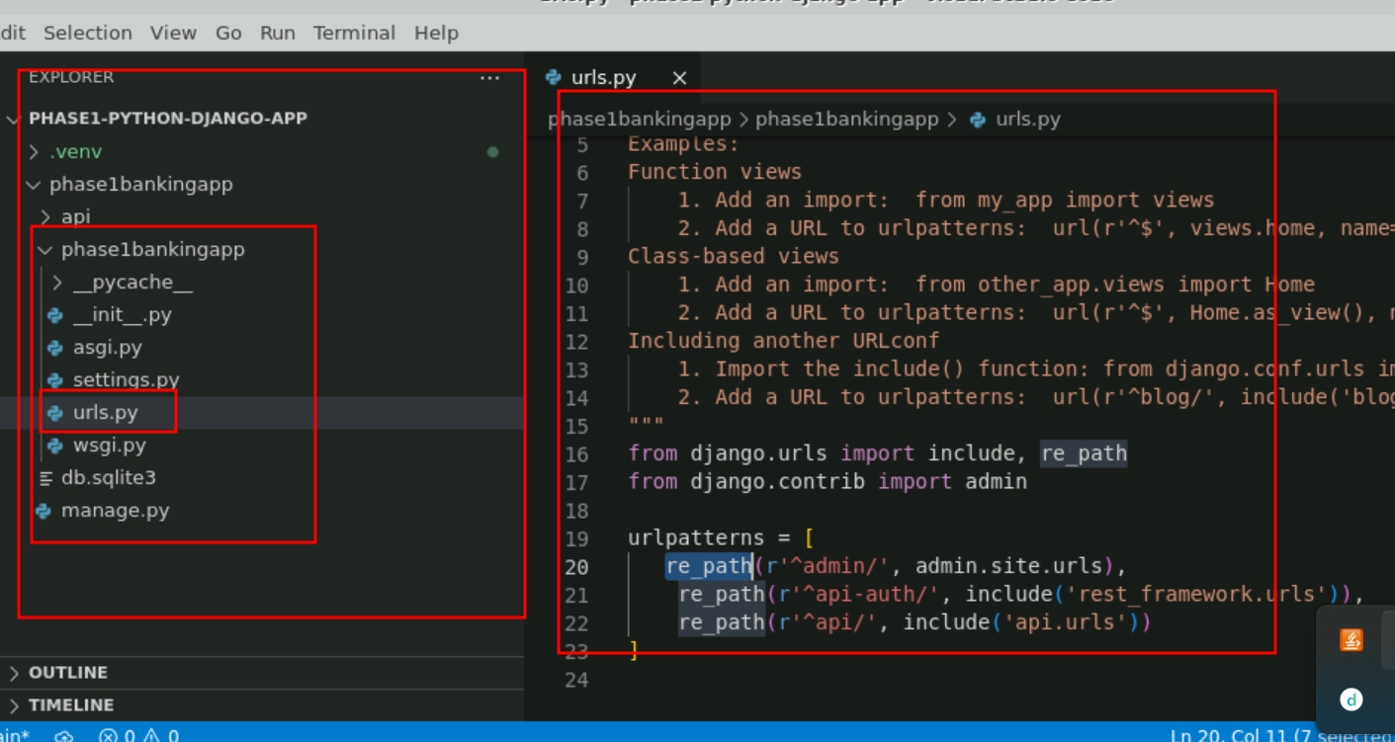

**Note** : Please refer phase1 project for all the python code.

* 1. Run the below commands to migrate models to the database   
     **python manage.py makemigrations**

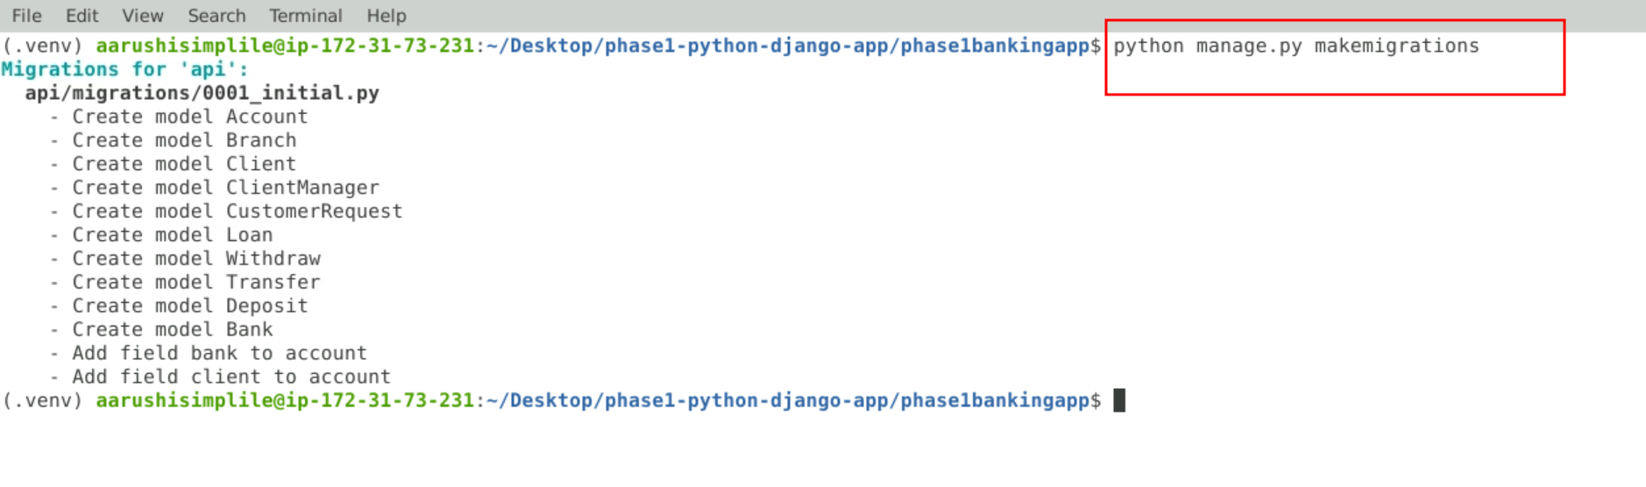

**python manage.py migrate**

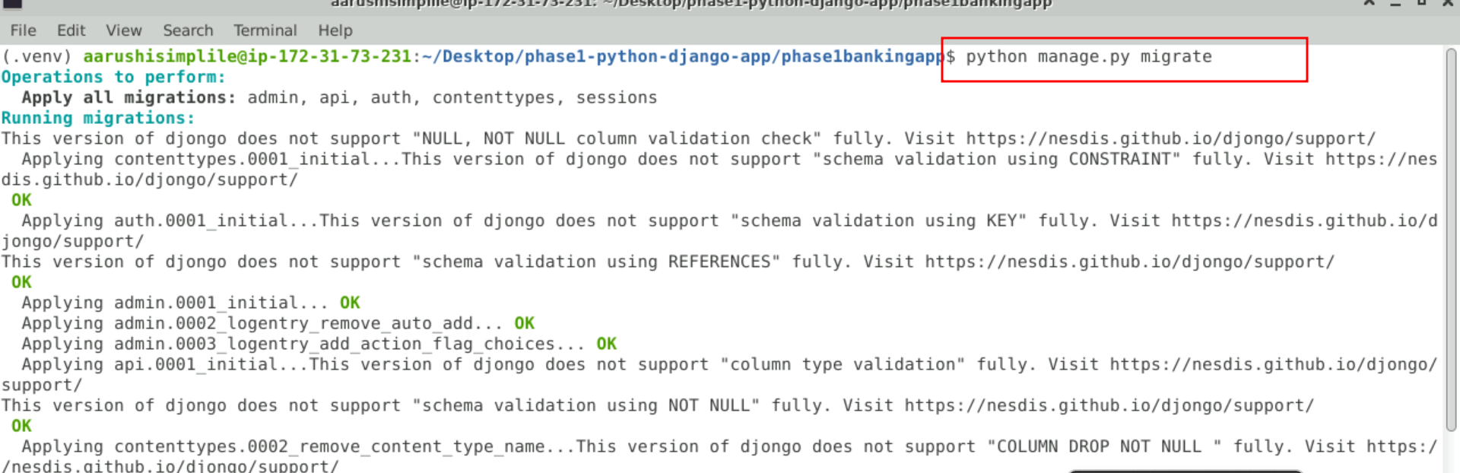

* 1. Check Mongo shell for the collections created mapping with the models

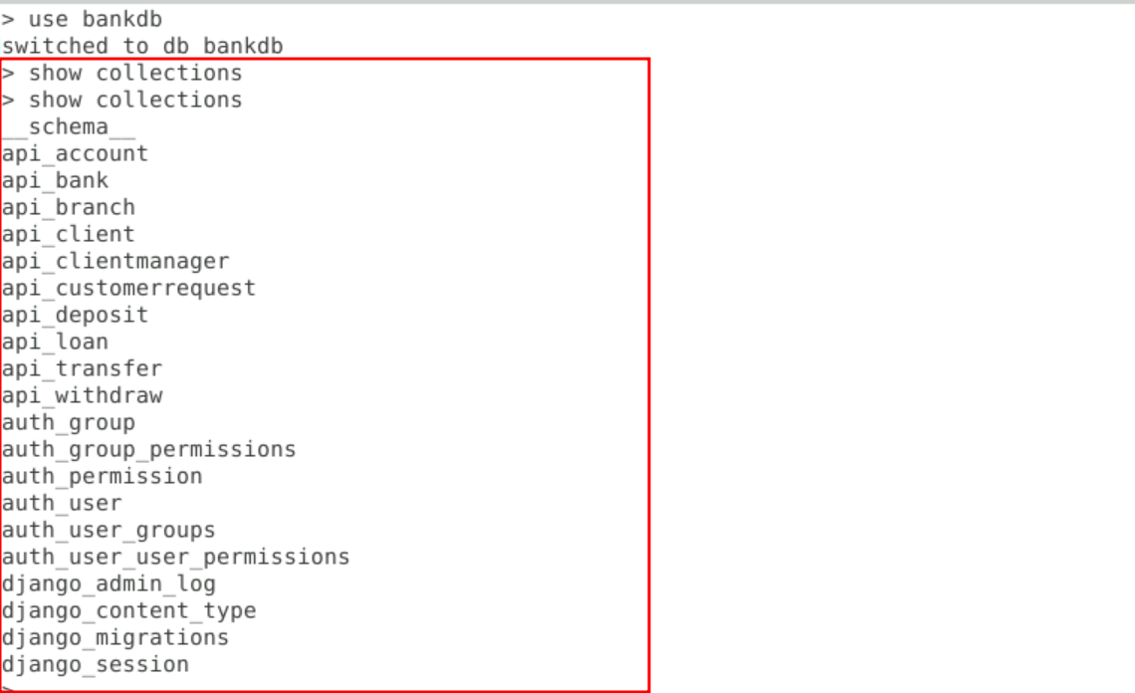

* 1. Update serializers.py and views.py (Refer to GitHub repo for code)
  2. Update root urls.py to include rentfurlax.urls as follows:  
      **from django.contrib import admin**

**from django.urls import path, include**

**from rentfurlax.views import \***

**urlpatterns = [**

**path('admin/', admin.site.urls),**

**path('', include('rentfurlax.urls')),**

**]**

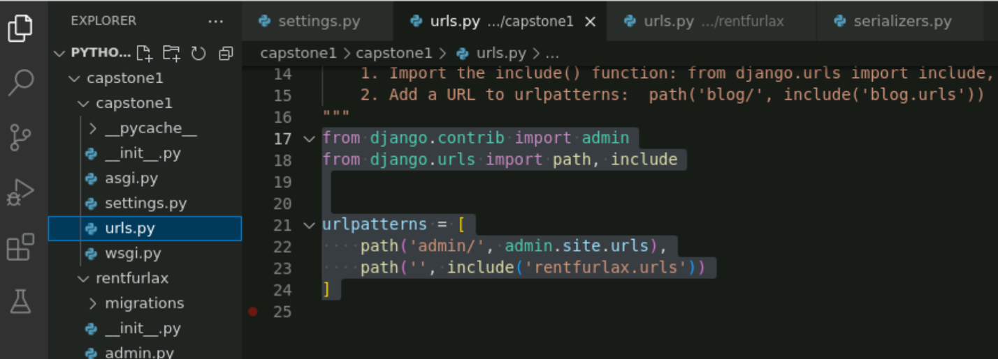

* 1. Run the project by executing the command   
     **python manage.py runserver**
  2. See the output on the browser as follows:

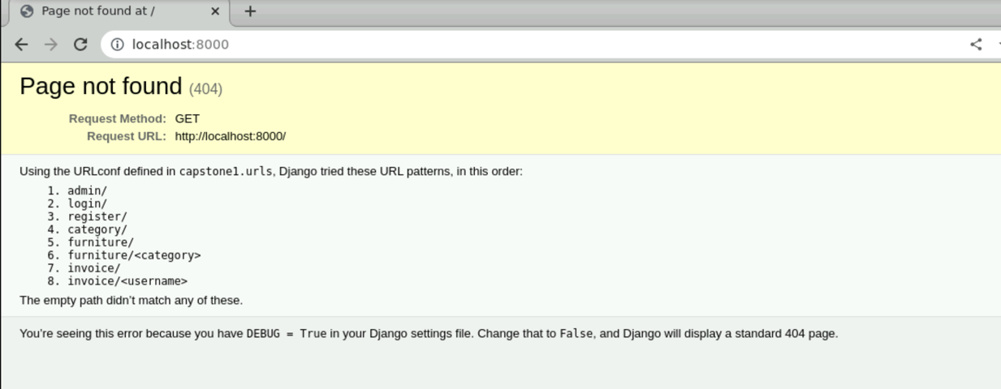

**Step 4: Executing the projects and testing in POSTMAN**

1. Open Postman
2. Register a customer:
   1. Failure message:  
      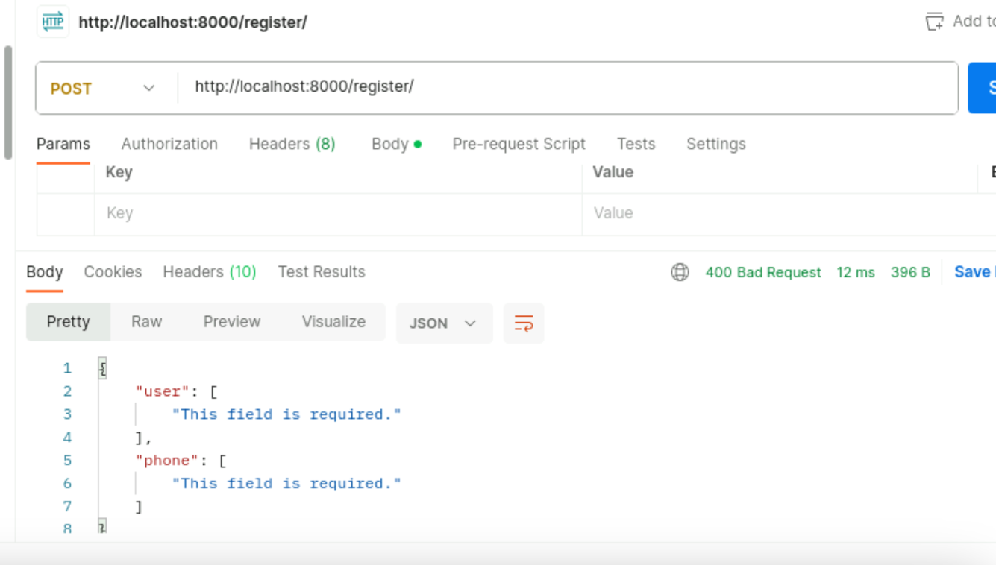
   2. Success message :   
      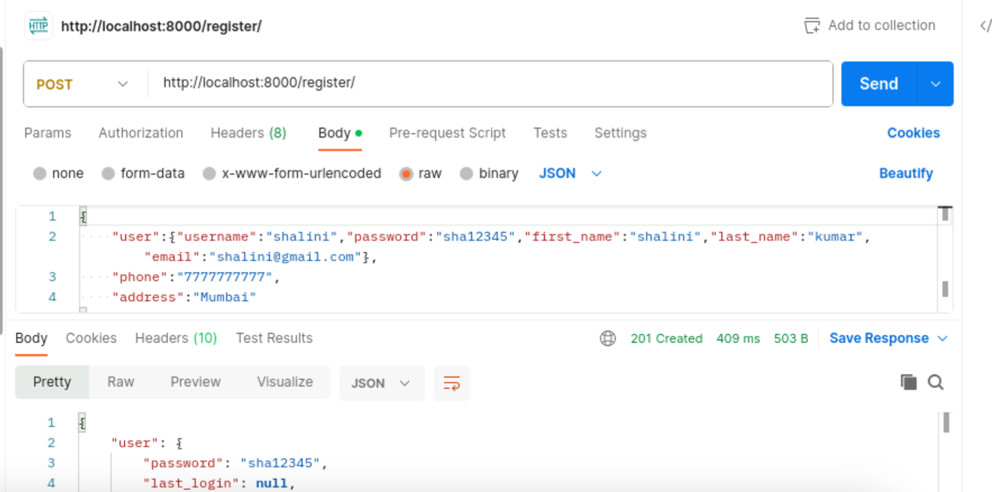
   3. Check in the database the record exists  
      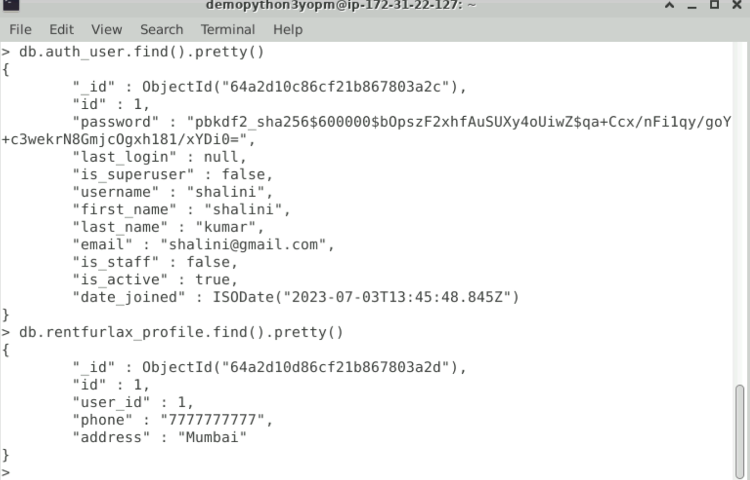
   4. If the same credentials exist, then give the following error:  
      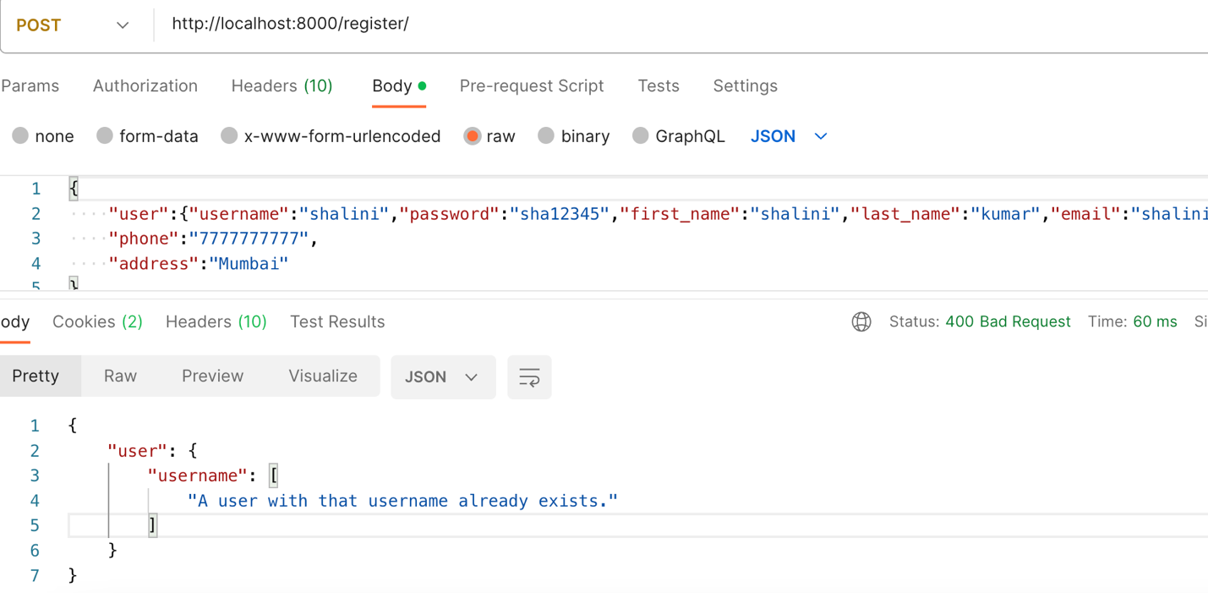
3. POST /login
   1. Success  
      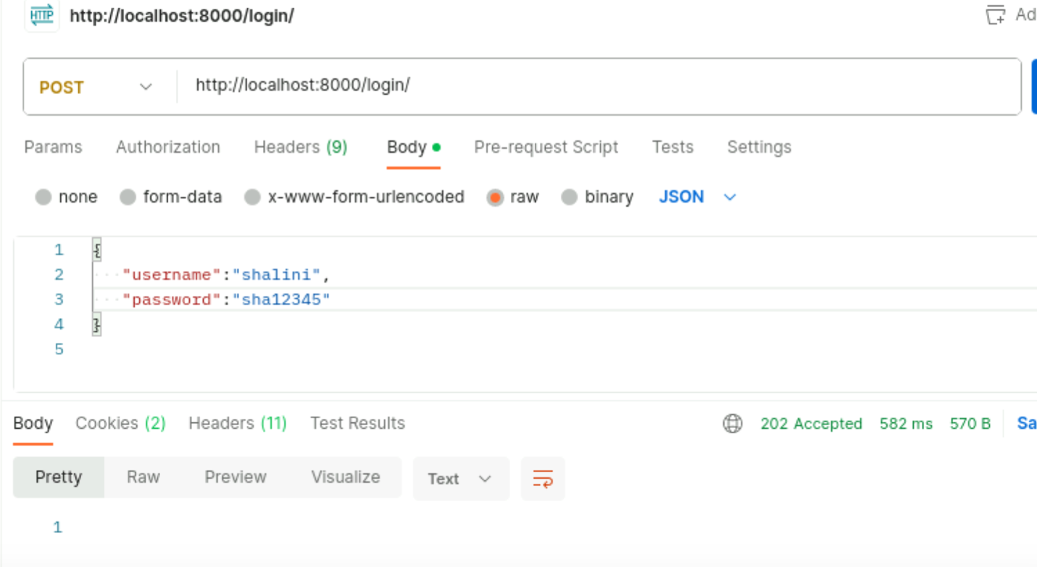
   2. failure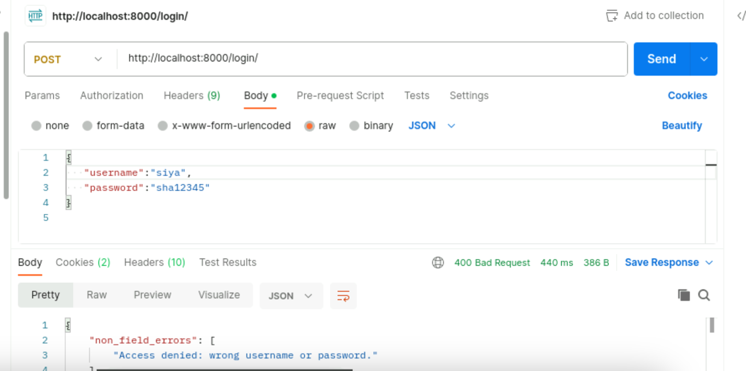
4. POST /category  
   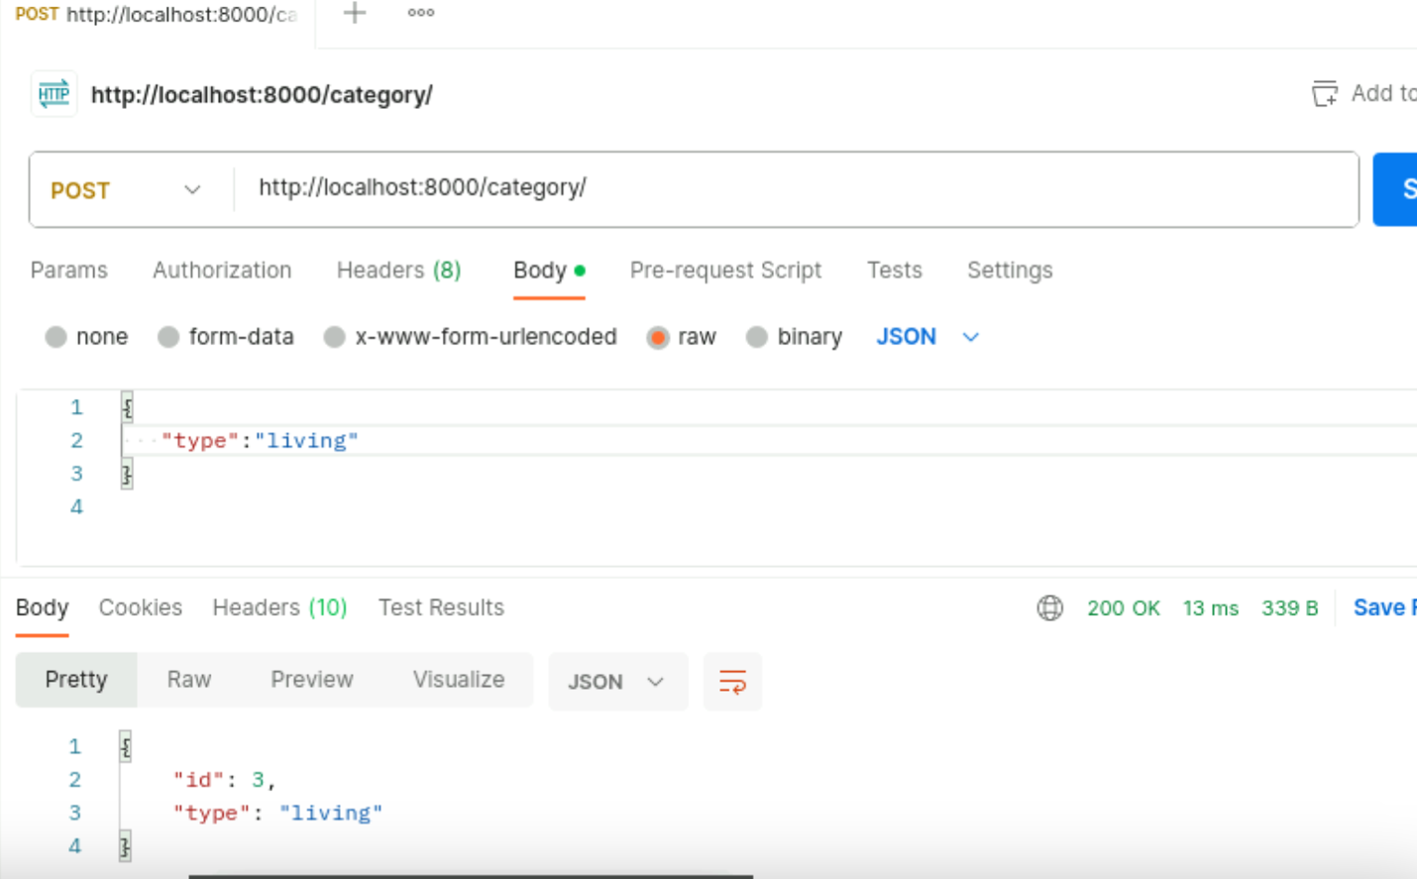
5. GET /category

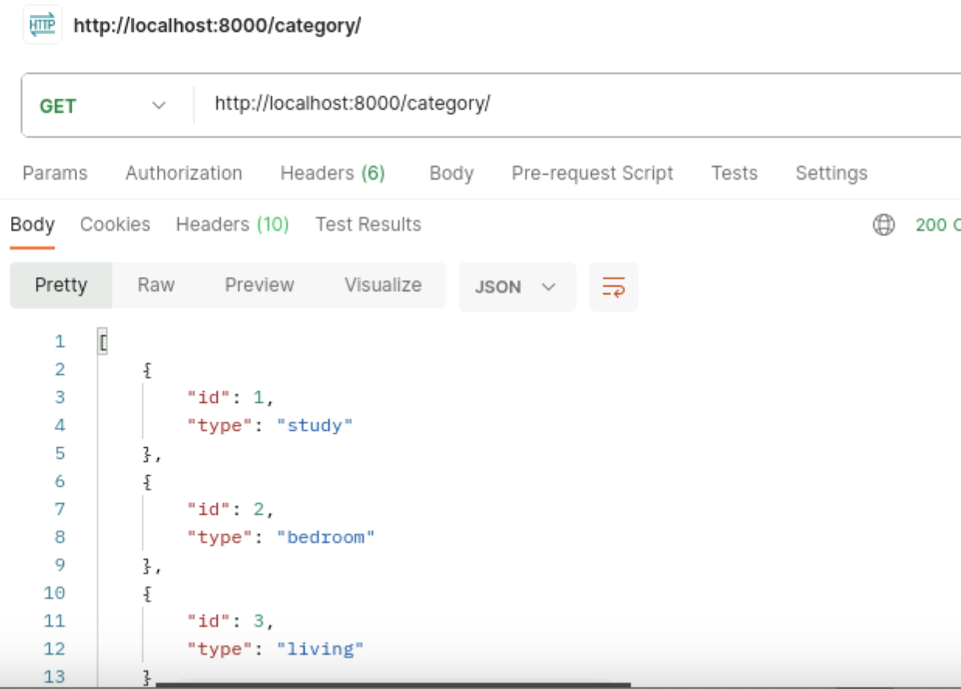

1. POST /furniture  
     
   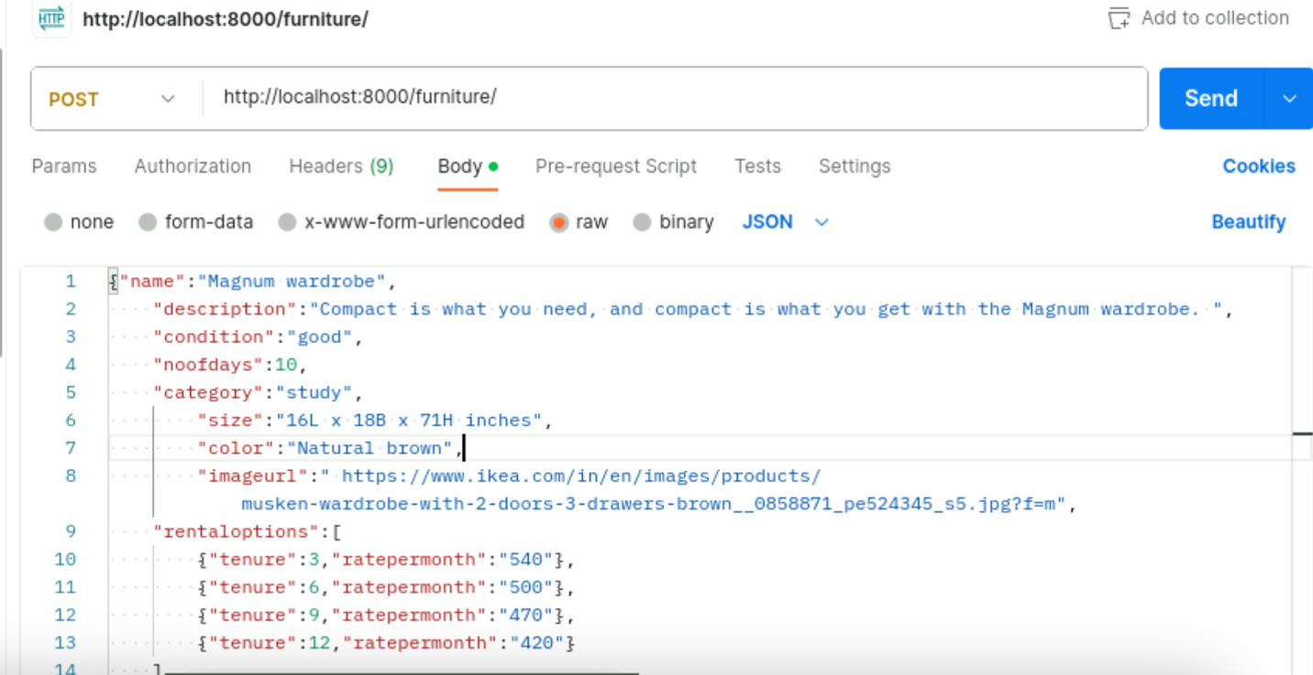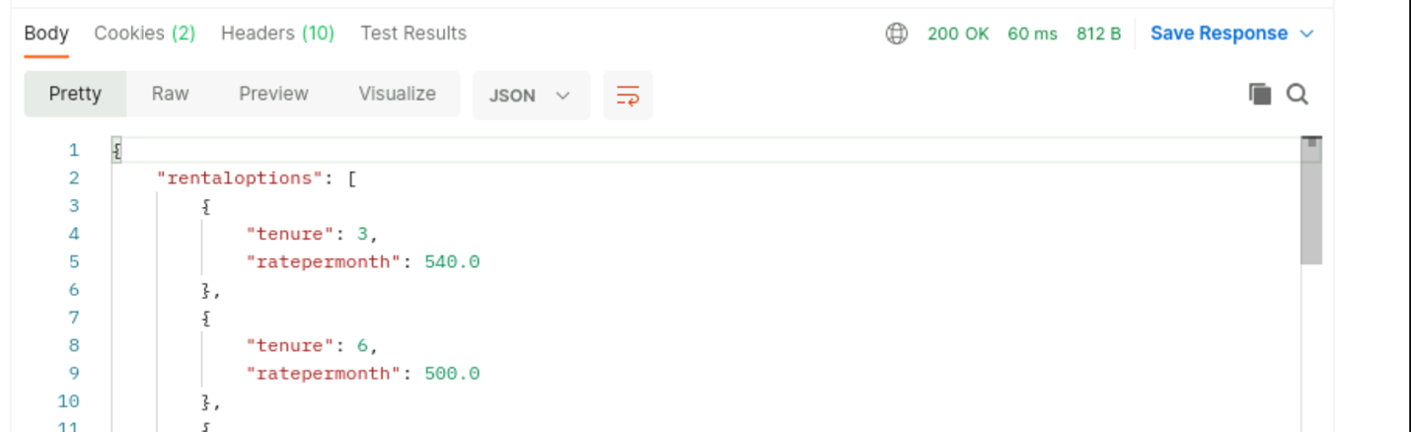

Check in database  
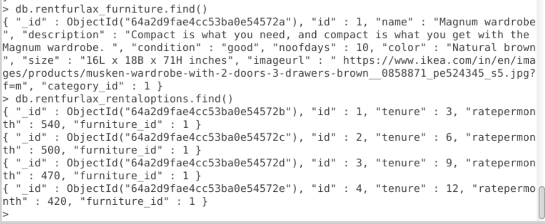

1. GET furniture/study  
   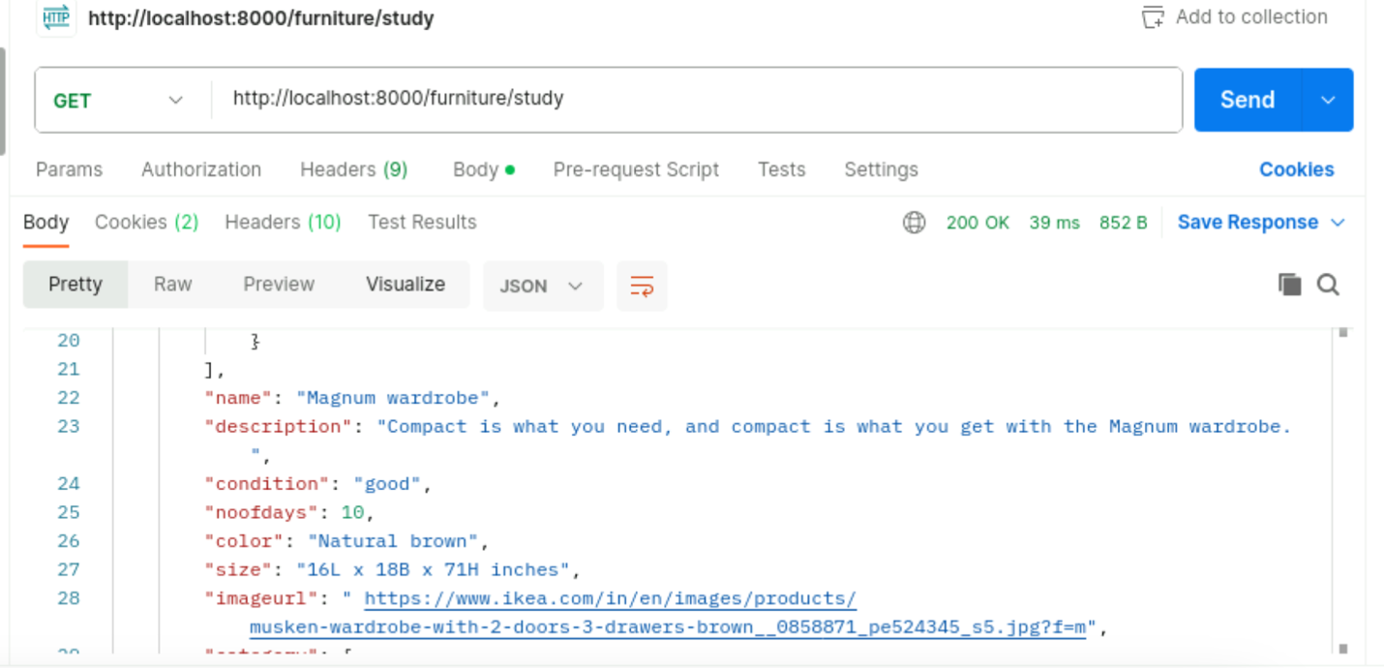
2. GET furniture/bedroom  
   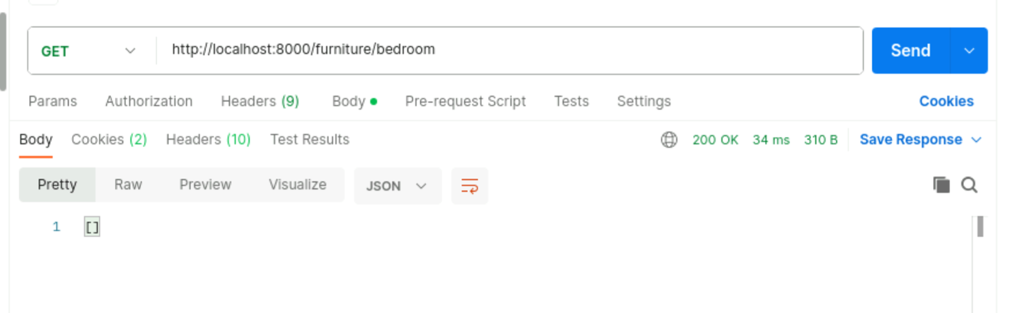
3. **POST invoice/  
   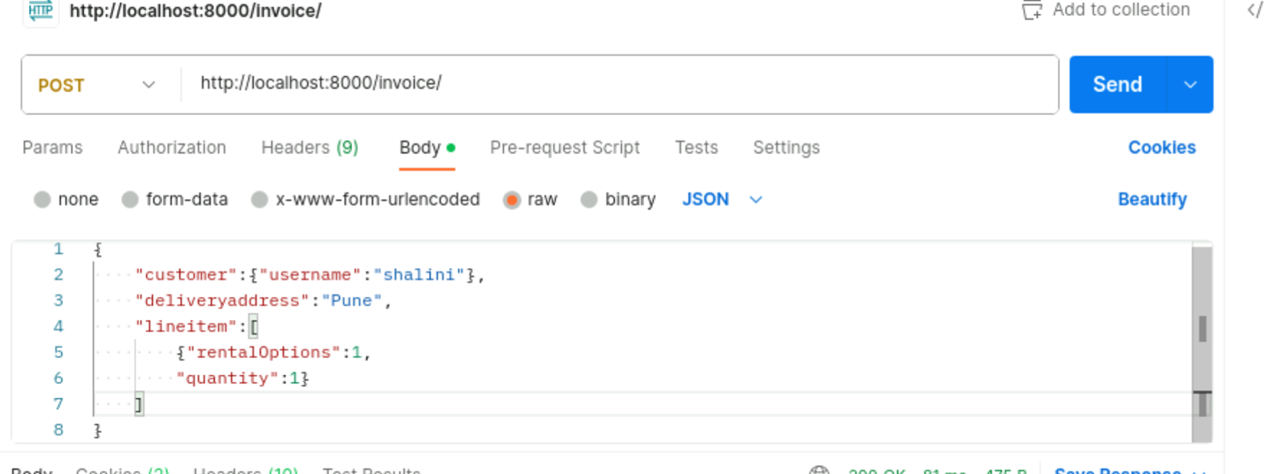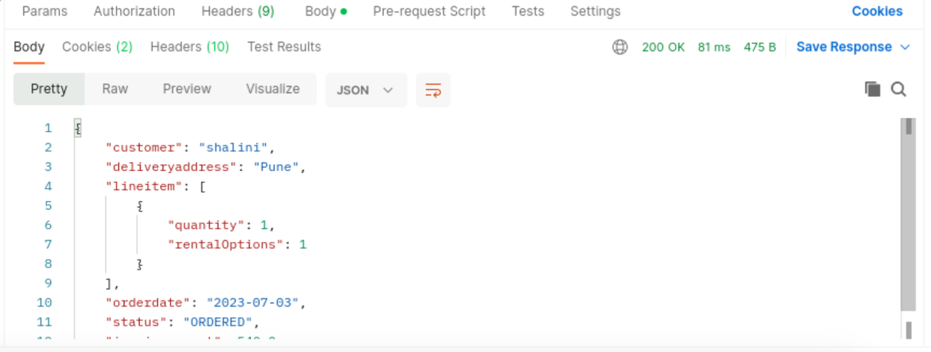**

**Check database  
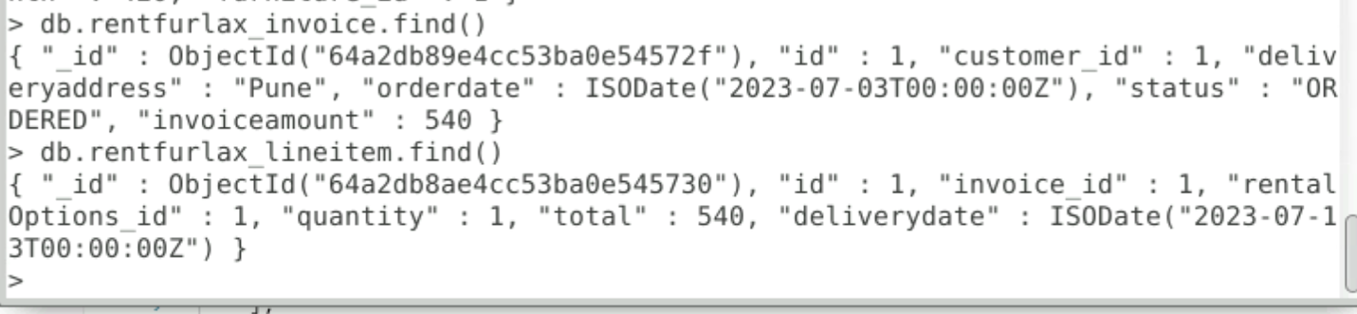**

1. **Get invoice/Shalini  
   